Methods 1 Exam 1 Review

1. Assume that a group of fishermen catch, on average, 50 fish a day. Each fish, when sold, is worth $25. What is the probability that the fishermen make exactly $1,375 in one day?
   1. 6%
   2. 54%
   3. 23%
   4. 4%
2. Using the same assumptions, what is the probability that the fisherman make between $1125 and $1375 in a single day.
   1. 56%
   2. 52%
   3. 2%
   4. 45%
3. Assuming that one day’s catch doesn’t affect another day’s catch, what is the probability that they will catch more than 50 fish every day for a single week.
   1. 46%
   2. .5%
   3. 54%
   4. 1%

|  |  |  |  |
| --- | --- | --- | --- |
|  | Not A | A | Total |
| Not B | 52 | 94 | 146 |
| B | 9 | 6 | 15 |
| Total | 61 | 100 | 161 |

1. Give the 2x2 table above, what is the probability of $A∩B$?
   1. 32%
   2. 96%
   3. 6%
   4. 4%
2. What is the probability of A|B?
   1. 40%
   2. 60%
   3. 94%
   4. 6%
3. What is the probability of B|A?
   1. 40%
   2. 60%
   3. 94%
   4. 6%
4. What is P(A)?
   1. 62%
   2. 38%
   3. 58%
   4. 9%
5. What is P(B)?
   1. 62%
   2. 38%
   3. 58%
   4. 9%
6. Are A and B independent?
   1. Yes
   2. No

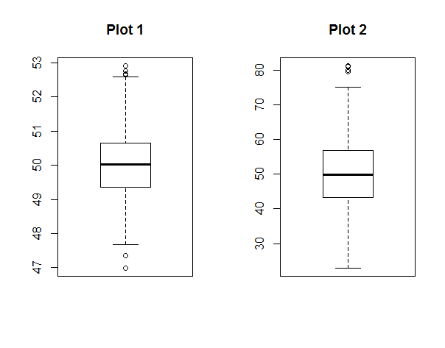

1. Which plot would you expect to have a larger standard deviation?
   1. Plot 1
   2. Plot 2
   3. Both plots have approximately the same standard deviation.
2. Which plot has the larger mean?
   1. Plot 1
   2. Plot 2
   3. Both plots have approximately the same mean.
3. Which plot has the larger range?
   1. Plot 1
   2. Plot 2
   3. Both plots have the same range

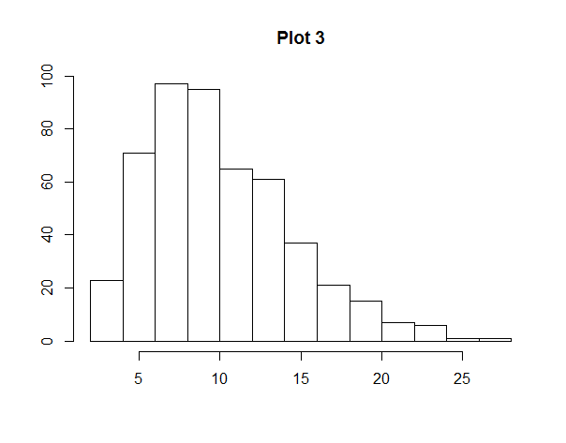

1. Which of the following is true regarding the data in Plot 3?
   1. The mean is greater than the median.
   2. The median is greater than the mean.
   3. The mean and median are equal.
   4. The data is skewed to the left.
   5. The data is skewed to the right.
   6. The data is symmetric.
2. When is the normal approximation to the binomial acceptable?
   1. When n is small and p is close to 0 or 1.
   2. When n is small and p is not very close to 0 or 1.
   3. When n is large and p is close to 0 or 1.
   4. When n is large and p is not very close to 0 or 1.
3. Given that, for a certain dataset, the E(x) is 15 and Var(X) = 1, what is a = E(2*X-5) and b = Var(-3*X+7)?
   1. a = 35 , b = 142
   2. a = 25, b = 9
   3. a = 35, b = -4
   4. a = 25, b = 16
4. What is the mean and standard deviation of a standard normal distribution?
   1. Mean = 1, standard deviation = 1
   2. Mean = 0, standard deviation = 1
   3. Mean = 1, standard deviation = 0
   4. Mean = 0, standard deviation = 0
5. A dataset has a mean of 100 and a standard deviation of 15. What is the standard error if the sample size is 9? What if the sample size is 25?
   1. 5, 3
   2. 1.67, .6
   3. 11, 4
   4. 6 , 5
6. Assume that the probability of drinking at least one cup of coffee in a day is .25. In a room of 25 random people what is the probability that 10 people have had or will have at least one cup of coffee that day?
   1. 4%
   2. 97%
   3. 0%
   4. 100%
7. What is the probability that between 4 and 7 people drink at least one cup of coffee in a day?
   1. 51%
   2. 63%
   3. 10%
   4. 3%
8. What is the probability that more than 7 people drink at least one cup of coffee in a day?
   1. 85%
   2. 73%
   3. 27%
   4. 15%